6
Digital Design and Computer Architecture

Lab 7: Digital System Design – Single Path RISC Architecture – Part II

The Goal of Lab 7 is to implement I-type instructions.
6
We will follow the single datapath RISC architecture to achieve 2 types of operations: LW, SW.

Textbook Reading
Read Chapter 6 on I Type instructions (6.3.2)
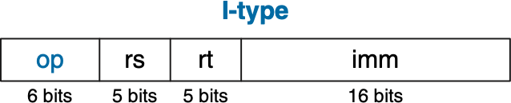

and Chapter 7 on Single Cycle Microarchitecture (see the appendix for more information).

To simplify the design, we modify the original RISC instruction op field for I-type and R-type instructions. Here, to control the 3 MUXs and ALU (RegDst, ALUSrc, ALUControl2:0, MemtoReg), we use op. The fields of op are shown below.
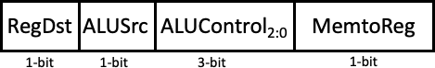
Examples on how to represent our operations (LW, SW) into I-type instructions and how the instructions work in RISC datapath architecture:
Note: Assume all the data in Register File is initialized as 0.

- LW(Load) in I-type instruction
Load Data_Memory[5] to Register_File[1]. The base address rs = 0, offset imm = 5. So Address of Data_Memory = Register_File[rs] + imm = 5
The address of Register File rt = 1

In this case, RegDst = 0, ALUSrc = 1, ALUControl[2:0] = 010(ADD), MemtoReg = 1, so: op = 6'b010101
rs = 5'd0 = 5'b00000 rt = 5'd1 = 5'b00001
imm = 16'd5 = 16'b0000_0000_0000_0101
So the I-type instruction should be: 32’b010101_00000_00001_0000_0000_0000_0101.
- SW(Store) in I-type instruction

Store Register_File[6] to Data_Memory[2]. The base address rs = 0, offset imm = 2. So Address of Data_Memory = Register_File[rs] + imm = 2.
The address of Register file rt = 6
In this case, RegDst = 0, ALUSrc = 1, ALUControl[2:0] = 010, MemtoReg = 0, so: op = 6'b010100
rs = 5'b00000 rt = 5'b00110
imm = 16'b0000_0000_0000_.0010
So the I-type instruction should be: 32’b010100_00000_00110_0000_0000_0000_0010.

Lab Tasks
[picking up from lab 5] Based on the “Register File” and “ALU” we implemented in Lab 5, in Lab 6, to achieve I-type instructions, we need to:

Implement the Data Memory
The module of the RISC data memory should look like this:
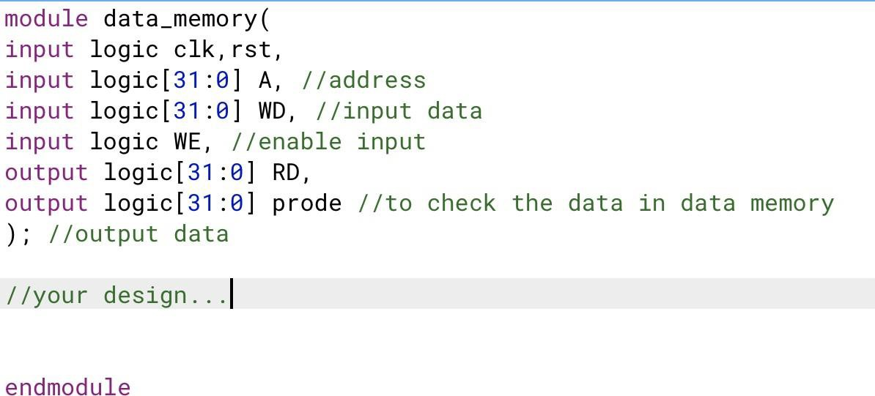
Notice for the Data Memory used here, we assume there are totally 256 32-bit registers, which means the width = 32 and the depth = 256.

Initialize the Data memory
Please initialize the Data Memory similarly to how you initialized the register file for Lab 5, following the example in Appendix 1.3.

Implement MUX

There are three MUXs here. MUX_MemtoReg, MUX_ALUSrc, MUX_RegDst.
They are very similar. Here is an example of the module definition of MUX_MemtoReg:
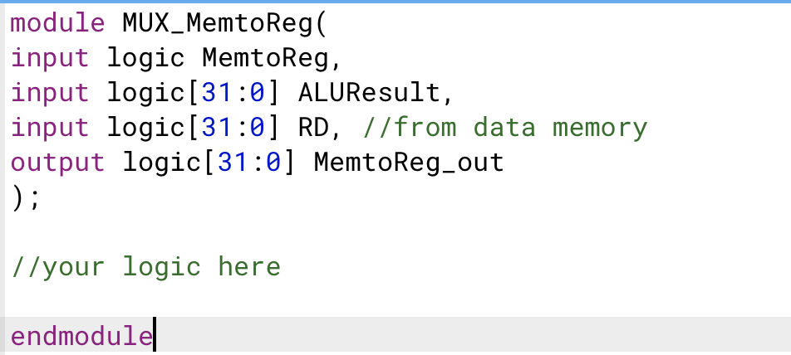
See Figure 7.9 in Appendix 1.0 for more information on these MUXs.

Implement Sign Extend
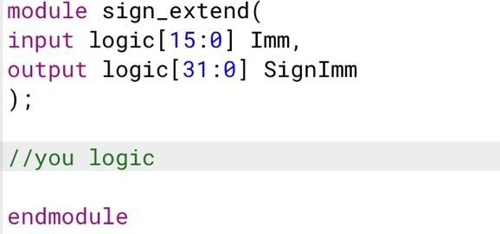
Sign Extend module is used to extend the sign bit of the 16-bit immediate to make it a 32-bit immediate for the ALU to do operations. See Appendix 1.2. for details.

Implement a top module
The top module should include: register file, data memory, 3 MUXs, Sign Extend, Display. You can take the top.sv provided in lab 5 as a reference.
Notice that for the Display module, you will only need it for in-lab 6, which means that it is not mandatory for pre-lab 6 implementation/report.

Use Testbench Waveform to verify
Write a testbench for the “top.sv” provided and verify your design in simulation. Follow the “testbench_top.sv” provided in Lab 5 as an example.
5
Use waveform file from lab 6 from Canvas.
Notice: For simulation result, please use the instructions from the above examples, i.e.
Show you correctly load Data_Memory[5] to Register_File[1]. The base address rs = 0, offset imm = 5.

Show you correctly Store Register_File[6] to Data_Memory[2]. The base address rs = 0, offset imm = 2

2.2 What to Turn In? Prelab – 2 points
- Due Date: Check Canvas

Pre-lab report:

You must submit an electronic copy of the following items (in the correct order, and each part clearly labeled) via Canvas. Submit it to the Lab 6 Pre-Lab Assignment. All items should be included in a single file (.pdf).

- A screenshot of your SystemVerilog Code for Data Memory.
- A screenshot of your SystemVerilog Code for 3 MUXs.
- A screenshot of your SystemVerilog Code for Sign Extend.
- A screenshot of your SystemVerilog Code for Top.
- Screenshots of your output waveforms using Waveform file in Modelsim
(Please set your output result radix as decimal to look clearer. It’s fine if you cannot fit in all your results in one screenshot, you can separate them into several screenshots)

In-Lab – 8 points
- Due Date: Check Canvas

In-lab report:

You must submit an electronic copy of the following items (in the correct order, and each part clearly labeled) via Canvas. Submit it to the Lab 7 In-Lab Assignment. All items should all be included in a single file (.pdf).

  - To the pdf document from your prelab assignment, just add a section for the in-lab assignment.
  - Take 2 pictures showing your results of LW, SW on the 7-segment display separately.
The LW will be loading data_memory[i] to register_file[1], where i is the first (MSB) digit of your board number.
The SW will be storing register_file[i] to data_memory[2], where i is the last (LSB) digit of your board number.

E.g. Your board number is 503, for LW, you will load data_memory[5] to register_file[1]. Make sure you record the board number and explain which registers you use in the in-lab report.

Appendix:

Introduction - General

For the following labs, we are going to design a simple digital system which is a demo of a modern computer with RISC architecture. Lab 7 is part 2 of the final lab, which is to implement a single datapath RISC architecture (shown below as Figure 7.9) using SystemVerilog.

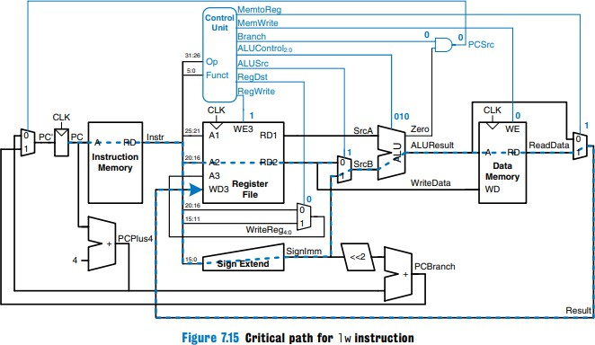

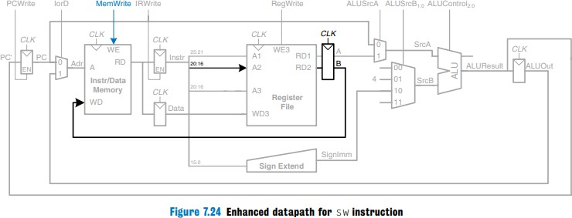

We use the single datapath RISC architecture to achieve 2 types of operations: LW, SW.
These 2 operations are represented into 32-bit I-type machine code in modern RISC computer architecture.

I-type Instructions

I-types instructions can be used to achieve LW and SW operations.

Figure 6.8 shows the format of an I-type instruction.

Figure 6.8 I-type instruction format
Within these 32 bits, the field rs (instr[25:21]), rt(instr[20:16]), imm(instr[15:0]) are used to point to operands. The field op (instr[31:26]) is used for operations.

[Important] The values stored in rs, rt also point to registers in the RF.
op in I-type instructions tells us to LW or SW. The example is given in the beginning.

Introduction - Single Datapath RISC Architecture
The main components in RISC architecture are shown below:

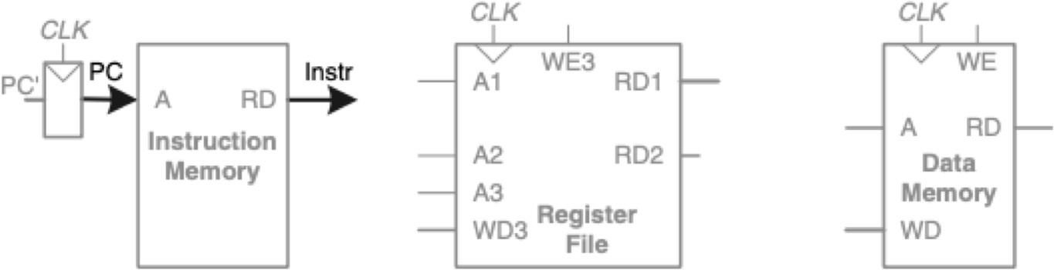
PC (Program Counter) contains the address of the instruction to execute.
Instruction Memory stores all the instructions. Port A requires the address of instructions. Port RD reads the instruction data. As shown here, PC connects to A and the Instruction Memory reads out the instruction from RD, labelled Instr.

Register File can read 2 registers and write 1 register simultaneously. For Register File, Port A1, A2, A3 are the input ports for address. Port RD1, RD2 are the output ports for read registers pointed to by A1 and A2, respectively. WD3 is the input port for writing data into a RF at the rising edge of the clock. WE3 is the write enable signal port.
Data Memory stores the data. Port A is the address input port. Port RD is the data output port. Port WD is the data input port. Port WE is the write enable port.

[Important] The above figure only shows the main component of a RISC architecture. A complete single datapath RISC architecture is given in Figure 7.9 above.

Introduction - How LW, SW works in RISC Architecture

Please refer to Chapter 7, Single-cycle Datapath (7.3.1) in textbook to see how LW, SW work in the single path RISC architecture. Here we give you a brief description on how those operations work in the RISC architecture (For details, you still need to go over the chapters/sections in the textbook stated in the beginning).
Note: To clarify, data in memory is represented as Memory[address]. E.g. the 1st data in Register File is Register_File[0], the second data in Data memory is Data_Memory[1], and so on.

LW and SW are I-type instructions and mainly provide data communications between the Register File and Data Memory. For LW, rs (instr[25:21]) are inputted in port A1 of Register File and Register_File[rs] (32-bit) is read out from port RD1. At the same time, imm (instr[15:0]) is extended through the Sign Extender and SignImm(32-bit) is obtained.
Register_File[rs] and SignImm are added together through ALU to get the memory address for data memory. The ALU result, in this case, is inputted to port A (see Figure 7.6 in the Textbook), and the Data Memory reads out Data_Memory[Register_File[rs] + SignImm] from port RD of Data Memory and inputted in port WD3 of Register File. Meanwhile, rt (instr[20:16]) is inputted in port A3 as the destination address for the Register File. So Data_Memory[Register_File[rs] + SignImm] is loaded from Data Memory to Register_File[rt]. For SW, it is very similar; please review section 7.3.1 of the textbook.

